1. first of all，Copy unzip “Driver.zip”four files to C\Windows\inf document，copy version。
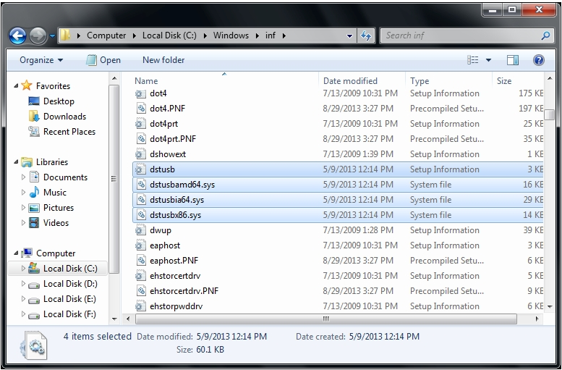
2. open device manager，choose "Gadget Serial V2.4" ，right menu “Update the driver”
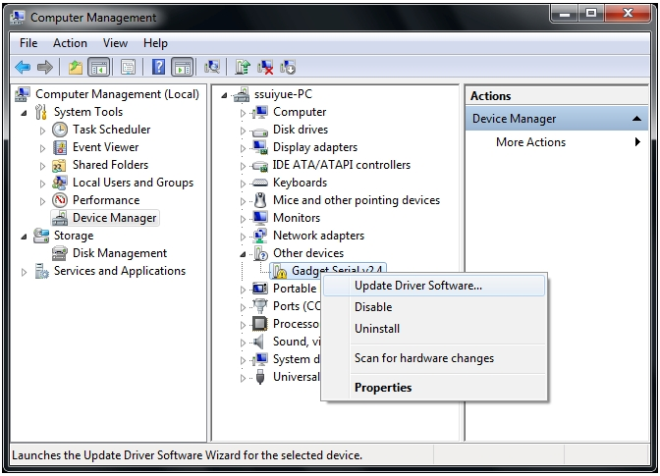
Select "Browse my computer for driver software".
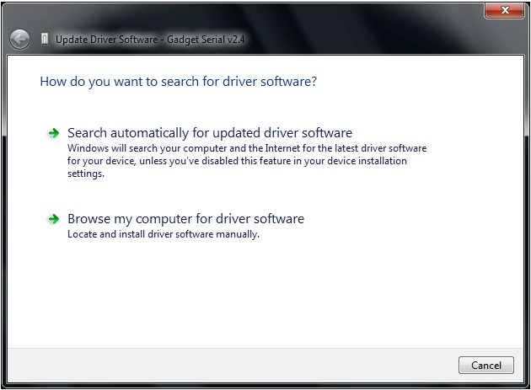
3. Select driver location "C\Windows\inf".
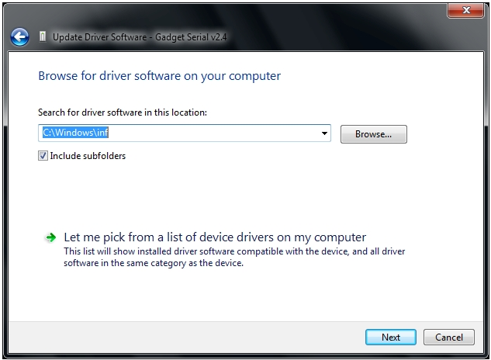
Select "Install this driver software anyway".

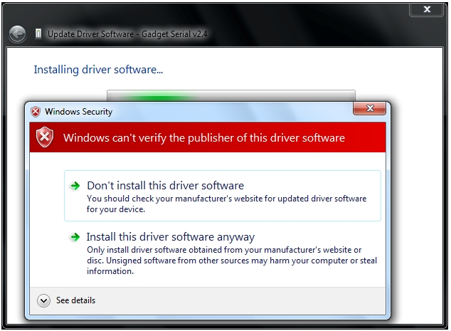

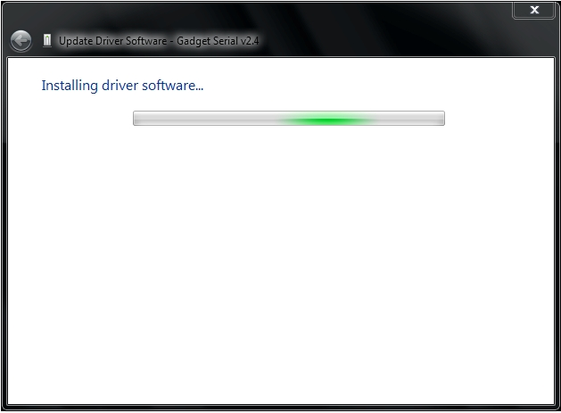

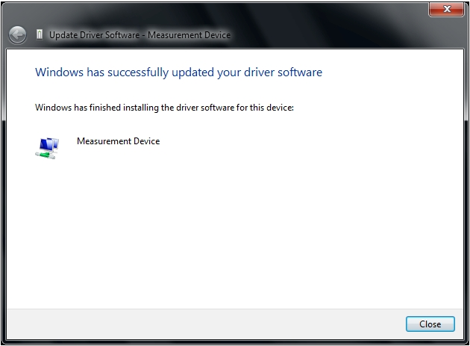

Installation successful。

